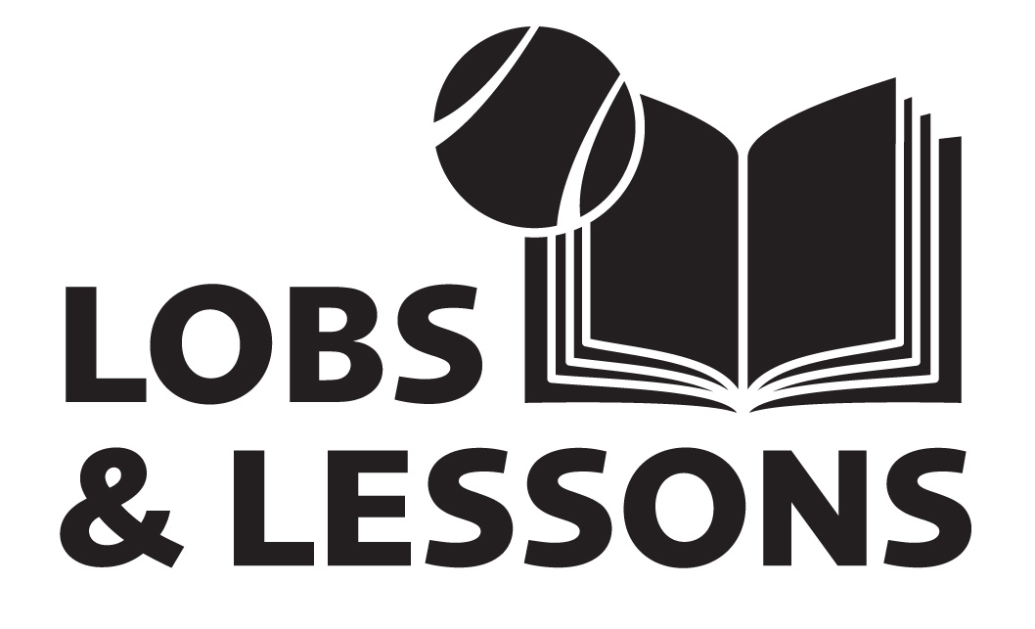

2014-15 PARENT PERMISSION FORM
DIVISION OF COMMUNITY ENGAGEMENT YOUTH PROGRAMS

Program Participation
I give permission for my child to participate in the Lobs & Lessons program located on the Virginia Commonwealth University (VCU) campus. I understand that Lobs & Lessons will provide supervision for program activities. I understand that accidents may occur from my child’s participation in the program activities, including but not limited to, life skills, sports and field trips. I understand the risks associated with the activities and agree to assume these risks. I understand and agree that Lobs & Lessons, VCU, and its employees (or volunteers) will not be liable for injuries that may result from the program or its activities. I understand that Lobs & Lesson’s goal is to maintain a safe, educational environment and that if my child’s behavior is disruptive or in violation of Lobs & Lessons rules for student behavior he/she may be dismissed.
In case of illness or accident, I authorize and direct Lobs & Lesson’s personnel to seek emergency medical care or take other action they believe is necessary under the circumstances to protect the best interest of my child. If my child is taken for emergency medical treatment, I hereby authorize the attending physician to administer the emergency treatment he/she believes is appropriate, and I agree to pay the resulting expense.
I certify that I am the child’s guardian and have full power, right and authority to enter into this release on behalf of the child and understand all of its terms and provisions.
Child’s Name |  | Parent/Guardian Printed Name
Parent/Guardian Signature |  | Date

Evaluation
VCU Division of Community Engagement is committed to ensuring that your child receives the highest quality services possible. To that end, information will be collected for internal evaluation purposes only. This information will be used solely to assist the VCU Division of Community Engagement in measuring effectiveness of the program.
I have read the form, understand it, and my signature below demonstrates that I have provided my consent for my child to participate in the Division of Community Engagement program under the terms described above.
Child’s Name |  | Parent/Guardian Printed Name
Parent/Guardian Signature |  | Date

